Name: Period: _

Biogeochemical Cycles WebQuest
FOR EACH CYCLE, VISIT THE URL ADDRESS PROVIDED. AT EACH WEBSITE YOU WILL NEED TO READ THE PASSAGES, ANSWER THE QUESTIONS, AND LABEL THE DIAGRAMS ON THIS WORKSHEET.

The Water Cycle (http://ga.water.usgs.gov/ed u/watercyclesummary.html)

- What percent of the earth's water is stored in the oceans of the world? _

- Explain the difference between evaporation and sublimation.

- Click the link evapotranspiration. What is evapotranspiration?

- How much water does an acre of corn transpire in one day? _ And a large oak tree in a year? _

- What 5 factors effect transpiration rate? Then navigate back to the summary page.

- Click the link stored as freshwater. What percent of our freshwater supply is found in: Glaciers and ice caps?
Ground water?
Surface water?
Other?

- When it comes to surface water storage, which lake holds a majority of the earth's freshwater supply? How much does it hold?
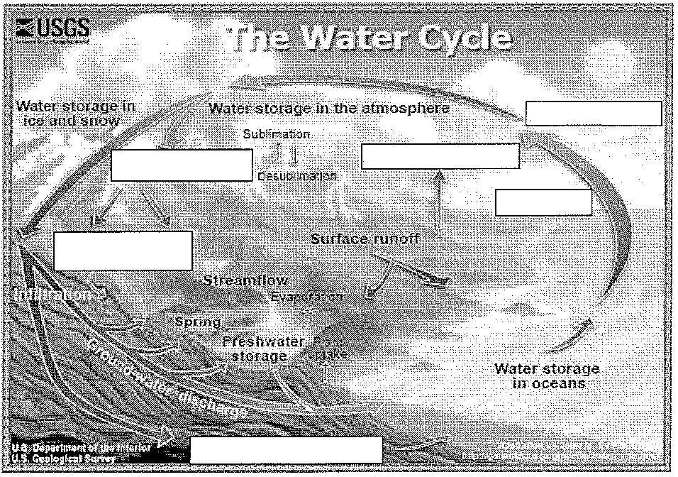

The Carbon Cycle

(http://www.windows2universe.org/earth/climate/carbon_cycle.html

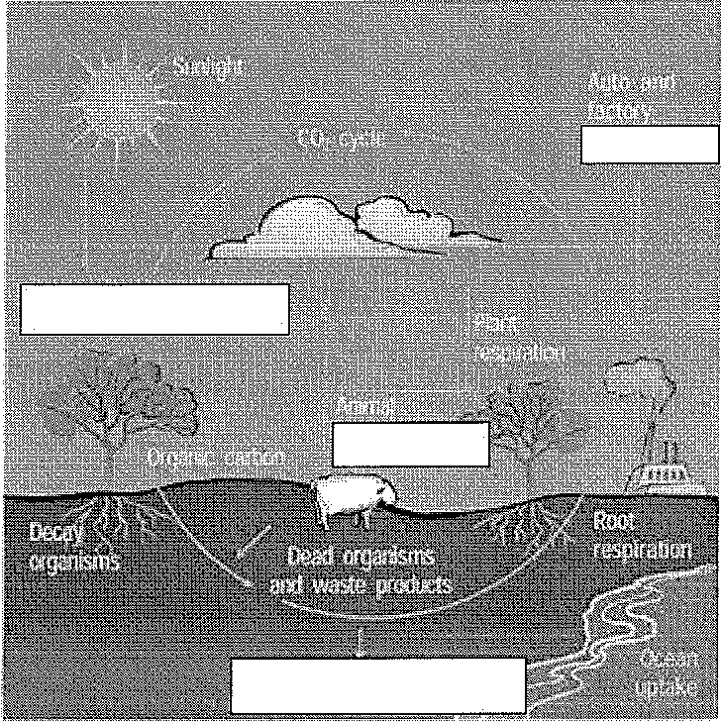
- In what form is carbon in the atmosphere?

- How does carbon move from the atmosphere to plants and then from plants to animals?

- How carbon move from plants and animals to the ground?

- How does carbon move from living things to the atmosphere? What is that process called?

- How much carbon is released each year from burning fossil fuels? Where does the carbon go?

- Carbon dioxide is a greenhouse gas. Why are greenhouse gases important to the survival of life on earth?

- Click on the link warmer. How much warmer is the planet today than it was 100 years ago?

- List the effects of global warming. Then navigate back to the page on the carbon cycle.

s

A

G
- s

H
- E
- E
- H

M
- w

s
- Besides coal and oil (fossil fuels) what type of rocks store a great deal of carbon?

The Nitrogen Cycle (http://www.visionlearning.com/library/module viewer.php?mid-98)
http://www.visionlearning.com/en/library/Earth-Science/6/The-Nitrogen-Cycle/98

- Nitrogen is a component of what 3 building blocks of life?

- What makes nitrogen in the atmosphere (N2) unavailable for use by living organisms?

- Write the chemical formula for nitrate , nitrite , and ammonium _

- Briefly define and distinguish between:

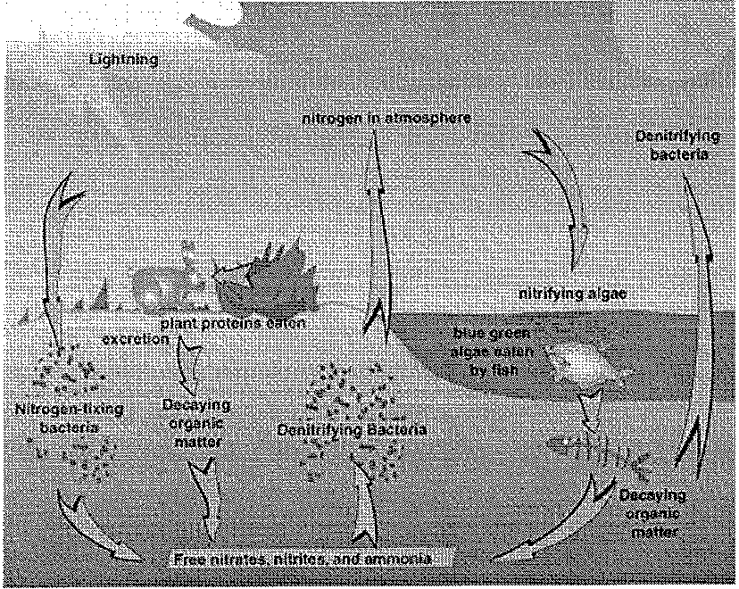
Nitrogen Fixation:

Denitrification:

Nitrification:

Nitrogen Mineralization:

Nitrogen Uptake:

- Name 3 ways that humans have impacted the nitrogen cycle.

- Click the "Questions & Quizzes" Tab and take the quiz. How did you score? _

- If you have time, navigate back to the nitrogen cycle module. Click of The Carbon Cycle link and take the quiz there too! How did you score? _

