Permanent Address: http://blogs.scientificamerican.com/observations/2015/01/15/humans-cross-another-danger-line-for-the-planet/

Humans Cross Another Danger Line for the Planet
By Mark Fischetti | January 15, 2015
advertisement
Five years go an impressive, international group of scientists unveiled nine biological and environmental “boundaries” that humankind should not cross in order to keep the earth a livable place. To its peril, the world had already crossed three of those safe limits: too much carbon dioxide in the atmosphere, too rapid a rate of species loss and too much pouring of nitrogen into rivers and oceans—primarily in the form of fertilizer runoff.
Now we have succeeded in transgressing a fourth limit: the amount of forestland being bulldozed or burned out of existence (see map below). Less and less forest reduces the planet’s ability to absorb some of that carbon dioxide and to produce water vapor, crucial to plant life. And the ongoing loss alters how much of the sun’s energy is absorbed or reflected across wide regions, which itself can modify climate.
Details about the fourth transgression, and updates on how well the planet is faring on all nine boundaries, are being published today online in Science. Another international team, with some of the same members from the original group, decided to reassess the boundaries given five more years of data, and they plan to keep doing so into the future. “Science moves on,” says the paper’s lead author, Will Steffen, a professor at the Australian National University and at the Stockholm Resilience Center at Stockholm University. “And so do the best ways to formulate the boundaries and apply them to policy.”

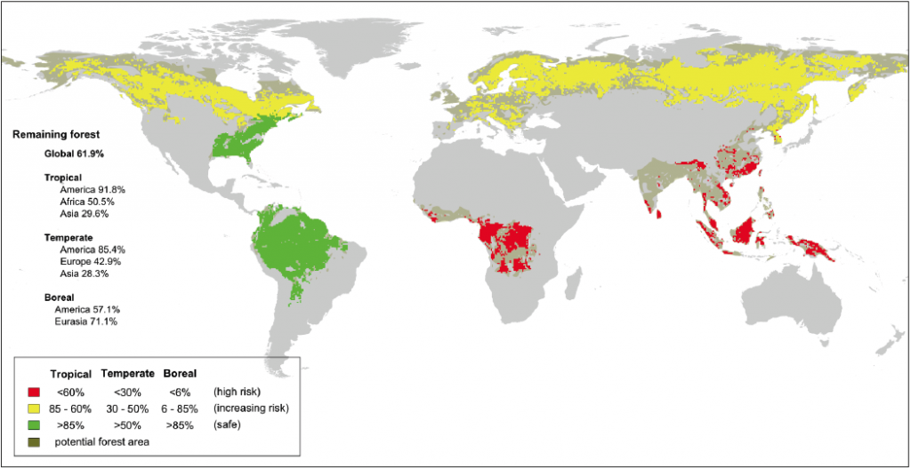
Disappearing Forests: Green are sustainable for now, yellow and red are past the safe limit.
Indeed, the group chose two “core boundaries,” each of which could “drive the earth system into a new state” if they are persistently surpassed. Of course the insinuation is that a “new” state is not a state we want to be in. The two core boundaries are “climate change”—primarily the amount of CO2 in the atmosphere—and “biosphere integrity,” which is how much we are killing off species and tearing up natural habitat. “Looking back into geologic history, we see that climate change and mass extinctions have occurred when major changes took place on earth,” Steffen says. Too much CO2 will simply cook the planet, and too much disruption of ecosystems will destroy natural resources (think food) on which people depend.
The designation of two core boundaries may in part be a response to frustration from policymakers when the nine boundaries were first revealed. They were simply too much for legislators and political leaders to take on. Steffen hopes that a focus on the core boundaries will guide the finalization of U.N. Sustainable Development Goals, happening this year, which are meant to guide nations in crafting policies that help sustain the planet into the future.
The researchers have put a surprisingly visual point on which nations bear the greatest responsibility for change by including detailed maps, like the forest map above, that show which regions are exceeding the boundaries the most. One set of maps, for example, shows which agricultural regions are sending the most nitrogen and phosphorous into waterways and oceans. When asked if the group might be criticized for pointing fingers, Steffen says, “That’s the reality of what’s happening. We’ve come to a point where we can’t avoid the equity issue any more,” meaning it is time to step up and indicate which countries are hurting the planet the most.
The realization that it is time to talk tough comes from a second new paper appearing today online in Anthropocene Review, also led by Steffen. It updates a striking set of 24 graphs (below) that show that almost all the damage to earth by humans has occurred since 1950, in lock step with rapid economic growth worldwide. This “great acceleration” of social, economic and environmental drivers basically says that although growing population adds stress to the earth’s systems, greater consumption through rising living standards is responsible for even more of the burden.
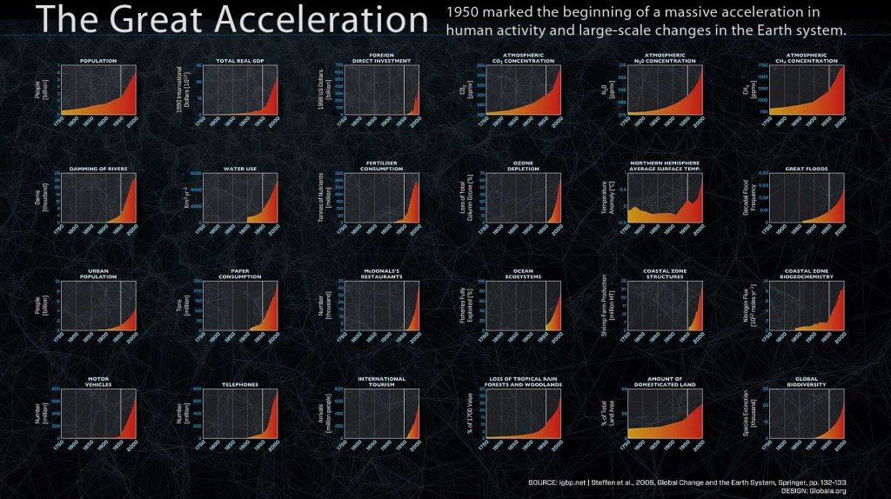
The “Great Acceleration” of social, economic and environmental drivers.
The knee-jerk reaction—that developing and poor countries cannot attain the income and quality of life levels enjoyed by fully developed nations without harming the earth—is wrong, however, Steffen says. For example, he notes, “We are not denying people food by saying the world must live within certain limits for nitrogen and phosphorous. Agronomists say new practices such as precision farming can allow us to grow enough food to feed 9 billion people and stay within the safe boundaries. We can be clever. We have tools. We just need to agree as a global society that we have to do things smarter.”
Part of scientists’ role in a smarter future will be to determine how the nine boundaries work together. Until now the limits have been assessed in isolation. Steffen says the next step, perhaps for a new report in another five years, is to unravel “the interactions between the boundaries. They are not independent of one another.” In the meantime, he adds, “we have to work with the policy community starting right now.”
Source for map: Planetary Boundaries: Guiding Human Development on a Changing Planet. Will Steffen et al. in Science, Jan. 15, 2015.
Credit for acceleration graphic: International Geosphere-Biosphere Programme
About the Author: Mark Fischetti is a senior editor at Scientific American who covers energy, environment and sustainability issues. Follow on Twitter @markfischetti.
More »

The views expressed are those of the author and are not necessarily those of Scientific American.

